**ECE 15200: Programming for Engineers**

**Purdue University Northwest, ECE Department**

Laboratory 4: Repetition

**Instructions**:

* Submit only C++ source files (*.cpp) for all the problems through Brightspace.
* Name each file following the format ***Lastname_*Lab*X*_p*Y*.cpp**, replace *Lastname, X,* and *Y* with your last name, lab #, and problem #, respectively.
* Put your name, assignment number, and date on the top of each source file (*.cpp) as multi-line comment given below:

/*

Class: ECE15200

Author: [Your Name]

Assignment: Lab [No.]

Date: [MM]/[DD]/[YY]

*/

Remove the brackets after updating the information in them.

* PLEASE WORK ALONE. If any plagiarism is found, you will get ZERO. Never hesitate to discuss with the instructor/TA if stuck in any assignment problem.

**Problem 1.** (Lastname_Lab4_p1.cpp) Input an integer x, output if it is a palindromic number. A palindromic number is a number that remains the same when its digits are reversed, e.g. 13531, 2552 [**20 points**].

**Hint**: use ‘while’, ‘*’, ‘/’ and ‘%’.

**Problem 2.** (Lastname_Lab4_p2.cpp) Write a program that calculates and displays the amount of money available in a bank account that initially has $8000 deposited in it and that earns interest at the rate of 2.5 percent a year. Your program should display the amount available at the end of each year for a period of 10 years. Use the relationship that the money available at the end of each year equals the amount of money in the account at the start of the year plus 0.025 times the amount available at the start of the year [**20 points**].

**Problem 3.** (Lastname_Lab4_p3.cpp) Write a program to calculate the sum of all prime numbers between 100 and 200, including. A prime number is a natural number greater than 1 and divided by 1 and itself only. For example, 5 is a prime number because 5 can only be divided by 1 and 5 **[30 points]**.

**Problem 4.** (Lastname_Lab4_p4.cpp) Write a program that prints the following shape. You may use output statements that print either a single asterisk (*) or a single blank. Maximize your use of repetition with nested **for** structure, and minimize the number of output statements [**30 points**].

*

***

*****

*******

*****

***

*

***

*****

*******

*****

***

*

**Problem 5 (Bonus).** (Lastname_Lab4_p5.cpp) Write a program to display the 9*9 multiplication table as shown in the following [**30 points**]:

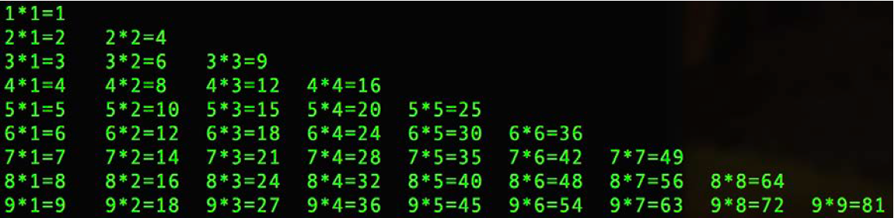

**Hint:** Consider row and column separately, totally 9 rows and 9 columns, use i to control rows and j to control columns.